World data

pp collisions at COSY

**Energy dependence of the Lambda/Sigma0 production cross section ratio in proton proton interactions**

|  |  |
| --- | --- |
| DOI: | [10.1140/epja/i2003-10236-6](https://arxiv.org/ct?url=http%3A%2F%2Fdx.doi.org%2F10%252E1140%2Fepja%2Fi2003-10236-6&v=22fe9082) |

**6 points from 13.9 to 59.2 MeV**

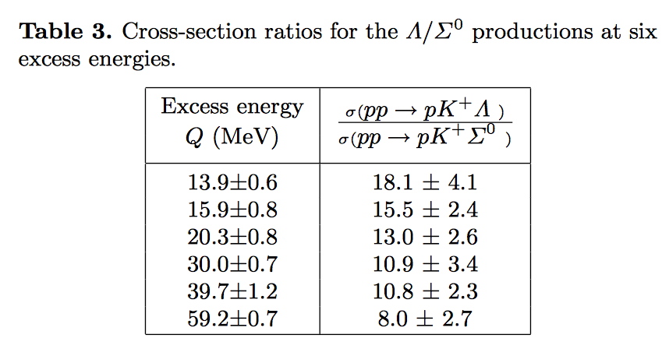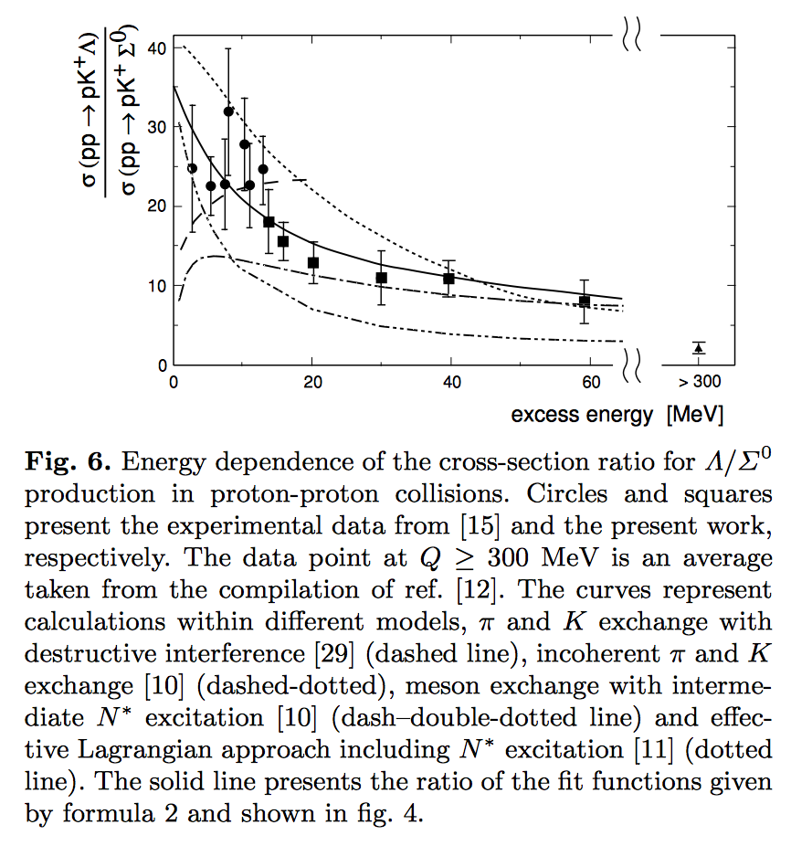

### [Comparison of Λ and Σ 0 Production near Threshold in Proton-Proton](https://www.google.co.kr/url?sa=t&rct=j&q=&esrc=s&source=web&cd=1&ved=0ahUKEwjusrrj_JvbAhXDIpoKHV5WDmkQFggpMAA&url=https%3A%2F%2Flink.aps.org%2Fdoi%2F10.1103%2FPhysRevLett.83.682&usg=AOvVaw1Kf3eHtA5YLtkr5hniupqK) collisions

DOI: <https://journals.aps.org/prl/pdf/10.1103/PhysRevLett.83.682>

<https://www.hepdata.net/record/42059?version=1&table=Table%201>

3 points 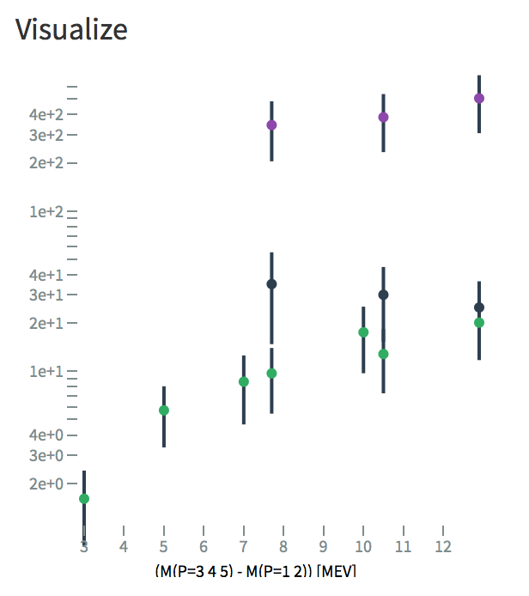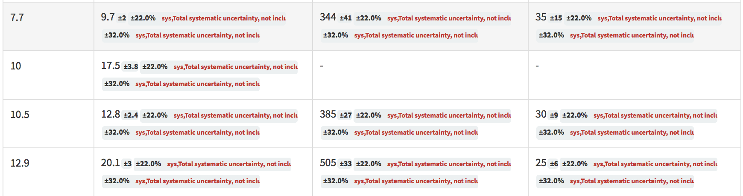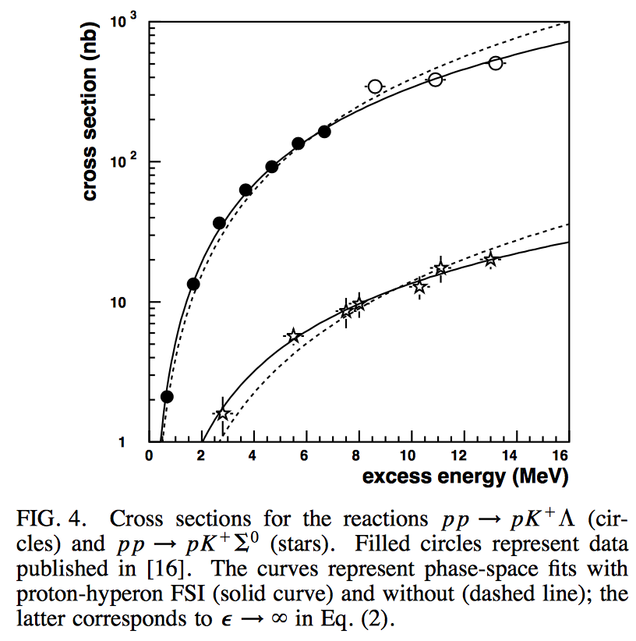at 7.7, 10.5 and 12.9 MeV

**Total cross-section of the reaction p p ---> p K+ Lambda close to threshold**

* DOI: [10.1016/S0370-2693(97)01527-X](https://doi.org/10.1016/S0370-2693(97)01527-X)